Implementation Guide
Microsoft Entra Privileged Identity Management (PIM)
MFA-Protected, Just-in-Time Elevation of the Microsoft Entra Joined Device Local Administrator Role
For Support Technicians Performing Local Administration on Entra-Joined Endpoints
Aligned with the Microsoft Entra ID Governance / PIM Advanced Deployment Guide
Version 1.0 | September 2026

Table of Contents
1. Introduction and Overview
2. Prerequisites and Planning
3. Navigate to Privileged Identity Management
4. Configure PIM Role Settings
5. Configure Assignment Duration Settings
6. Assign Eligible Members
7. Configure Device Local Administrator Role
8. Technician Activation Workflow
9. Monitoring and Auditing
10. Configure Security Alerts
11. Set Up Access Reviews
12. Governance Best Practices
13. Troubleshooting Guide
14. Rollback and Emergency Procedures
15. Implementation Summary Checklist

1. Introduction and Overview
Purpose. This guide provides step-by-step instructions for implementing Microsoft Entra Privileged Identity Management (PIM) to enable MFA-protected, just-in-time (JIT) elevation of the Microsoft Entra Joined Device Local Administrator role for support technicians who perform local administration on Microsoft Entra-joined endpoints.
Privileged Identity Management provides time-based and approval-based role activation to mitigate risks involving excessive, unnecessary, or misused access permissions. By configuring the device local administrator role through PIM, your organization ensures that support technicians receive local admin privileges only when needed, for a limited duration, and only after completing multifactor authentication.
This implementation aligns with the Microsoft Entra ID Governance PIM Advanced Deployment Guide and follows Microsoft best practices for least-privilege access, zero standing privileges, and continuous monitoring.
Naming Note
The role was formerly known as "Azure AD Joined Device Local Administrator." Microsoft renamed it to "Microsoft Entra Joined Device Local Administrator" as part of the Azure AD to Microsoft Entra ID rebranding. You may still encounter the legacy name in older documentation, PowerShell cmdlets, or portal interfaces. Both names refer to the same role.
Important Scope Limitation
The Microsoft Entra Joined Device Local Administrator role applies to ALL Microsoft Entra joined devices in the tenant. It cannot be scoped to a specific subset of devices. Any user assigned this role (whether active or activated through PIM) will have local administrator privileges on every Entra-joined device in the organization. Plan assignments accordingly.

1.1 What This Guide Covers
- Prerequisites, licensing, and planning considerations
- Configuring PIM role settings for the Microsoft Entra Joined Device Local Administrator role (MFA, justification, duration, approval)
- Assigning eligible members (individual users or role-assignable groups)
- The technician activation workflow (My Roles, MFA, justification, activate)
- Endpoint validation and timing for privilege propagation
- Monitoring, auditing, security alerts, and access reviews
- Governance best practices, troubleshooting, and rollback procedures

1.2 Key Concepts
- Eligible assignment: The user is assigned the role but must activate it before using it. Activation may require MFA, justification, or approval.
- Active assignment: The user always has the role privileges without any activation step. Not recommended except for emergency break-glass accounts.
- Activation: The process by which an eligible user temporarily elevates to an active role for a bounded duration.
- Just-in-time (JIT): Access is granted at the moment it is needed and automatically revoked after a set period, eliminating standing privileges.

2. Prerequisites and Planning

2.1 Licensing Requirements
Privileged Identity Management requires one of the following Microsoft Entra ID license plans:
- Microsoft Entra ID P2
- Microsoft Entra ID Governance
- Microsoft 365 E5 (includes Entra ID P2)
- Microsoft 365 E5 Security (includes Entra ID P2)
- Enterprise Mobility + Security (EMS) E5
Confirm that your tenant has sufficient licenses for all administrators who will be assigned eligible roles and all approvers who will review activation requests.

2.2 Administrative Role Requirements
The following roles are required to configure PIM and manage role assignments:
- Privileged Role Administrator - Required to configure PIM role settings and assign eligible role assignments. This is the primary role needed throughout this guide.
- Global Administrator - Can also manage PIM settings and assignments. Recommended for initial PIM enablement only; day-to-day operations should use Privileged Role Administrator.

2.3 Technical Prerequisites
- Target endpoints must be Microsoft Entra joined (not Entra registered or hybrid joined)
- Support technicians must have Microsoft Entra ID user accounts (cloud-only or synced)
- MFA must be configured for all eligible users (Microsoft Authenticator app recommended)
- If assigning eligibility through a group, the group must be a cloud-only, role-assignable group
- At least two emergency access (break-glass) accounts excluded from PIM and MFA lockout policies
- Devices must be running Windows 10 1709 or later for full local admin functionality

2.4 Planning Checklist
Before starting the implementation, complete the following planning activities:
- Identify the support technicians or groups who need local admin elevation
- Determine the maximum activation duration (recommended: 4-8 hours for support tasks)
- Decide whether approval is required for activation (recommended for production environments)
- Designate at least two approvers if approval is enabled
- Identify break-glass accounts that should be excluded from PIM
- Plan a pilot with 2-3 test users before full rollout
- Prepare communications for affected technicians explaining the new workflow
- Schedule a weekly audit review cadence

3. Navigate to Privileged Identity Management
The first step is to access the Privileged Identity Management module within the Microsoft Entra admin center. This is where all role settings, assignments, and activations are managed.

3.1 Access the PIM Module
Sign in to the Microsoft Entra admin center and navigate to the Privileged Identity Management module.
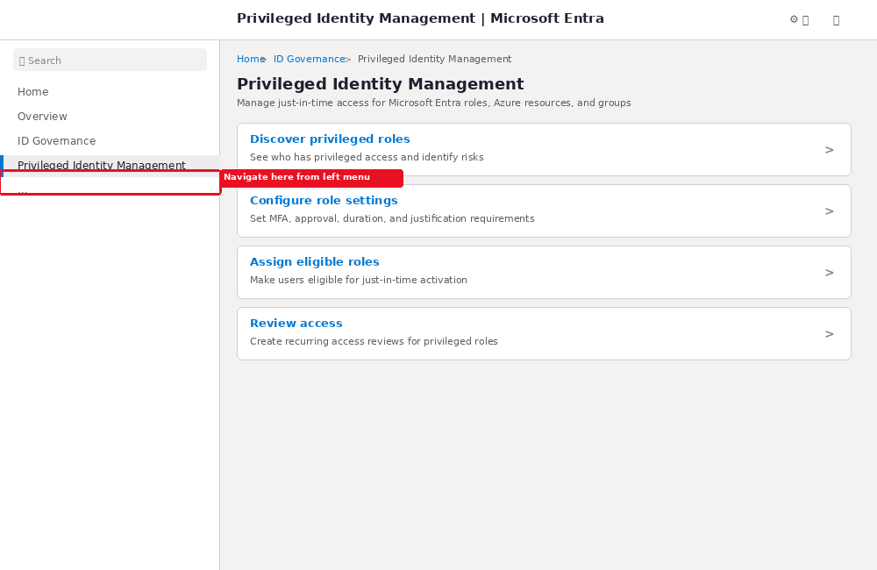
Figure 1. Illustrative portal mockup - PIM overview page in the Microsoft Entra admin center.

Click Path:
- Sign in to the Microsoft Entra admin center (https://entra.microsoft.com) as a Privileged Role Administrator or Global Administrator.
- Browse to ID Governance > Privileged Identity Management.
- The PIM overview page displays task cards for managing Microsoft Entra roles, Azure resources, and groups.
Tip
Bookmark the PIM page (https://entra.microsoft.com/#view/Microsoft_Azure_IAM/PIMV2MenuBlade) for quick access during day-to-day operations.

3.2 Navigate to Microsoft Entra Roles
From the PIM overview page, select Microsoft Entra roles to manage directory role assignments and settings.
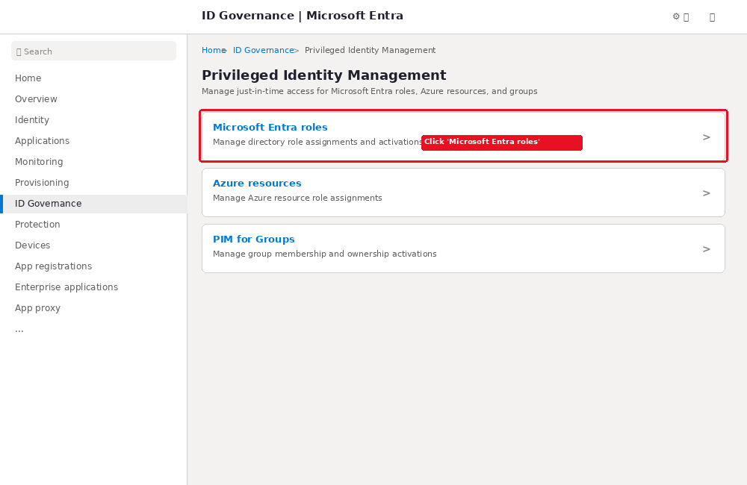
Figure 2. Illustrative portal mockup - Click "Microsoft Entra roles" to manage directory roles in PIM.

Click Path:
- Select "Microsoft Entra roles" (under Manage) from the PIM overview page.
- This opens the Microsoft Entra roles management page where you can view all roles, configure settings, and manage assignments.

4. Configure PIM Role Settings
Role settings define how the role can be activated, including MFA requirements, maximum duration, justification, and approval. These settings are configured per role and apply to all assignments of that role.
This is the most critical step in the implementation, as it defines the security controls that govern how support technicians elevate to local administrator.

4.1 Locate the Role
Navigate to the roles list and find the Microsoft Entra Joined Device Local Administrator role.
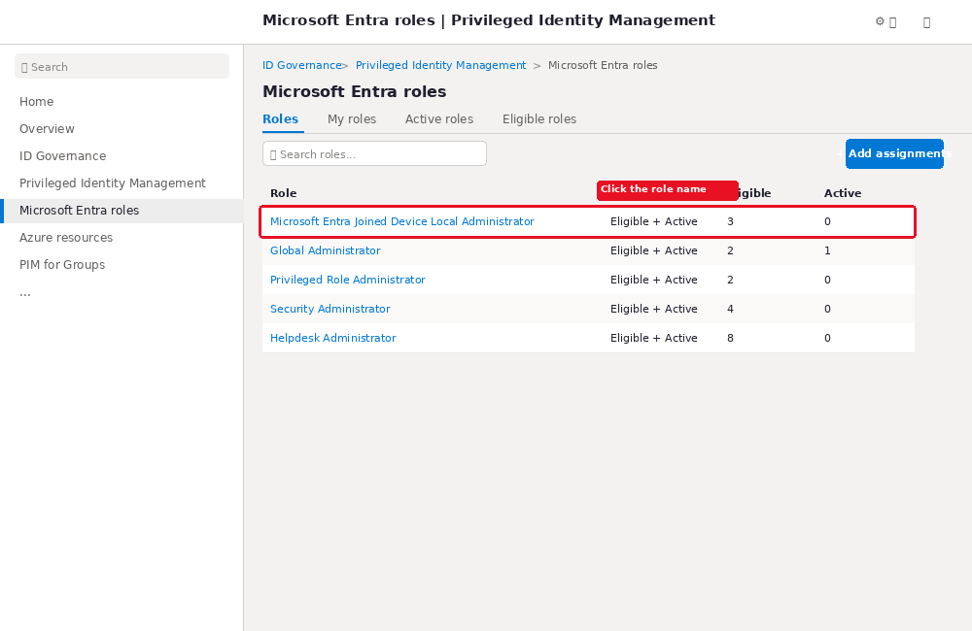
Figure 3. Illustrative portal mockup - Roles list in PIM. Click the role name to open its settings.

Click Path:
- Select "Roles" tab to see the list of all Microsoft Entra roles available in the tenant.
- Search for "Microsoft Entra Joined Device Local Administrator" or "Azure AD Joined Device Local Administrator" in the search box – you should find one or the other.
- Click the role name to open its detail page.

4.2 Open Role Settings
Once on the role detail page, navigate to the Role settings tab and click Edit to modify the PIM policy for this role.
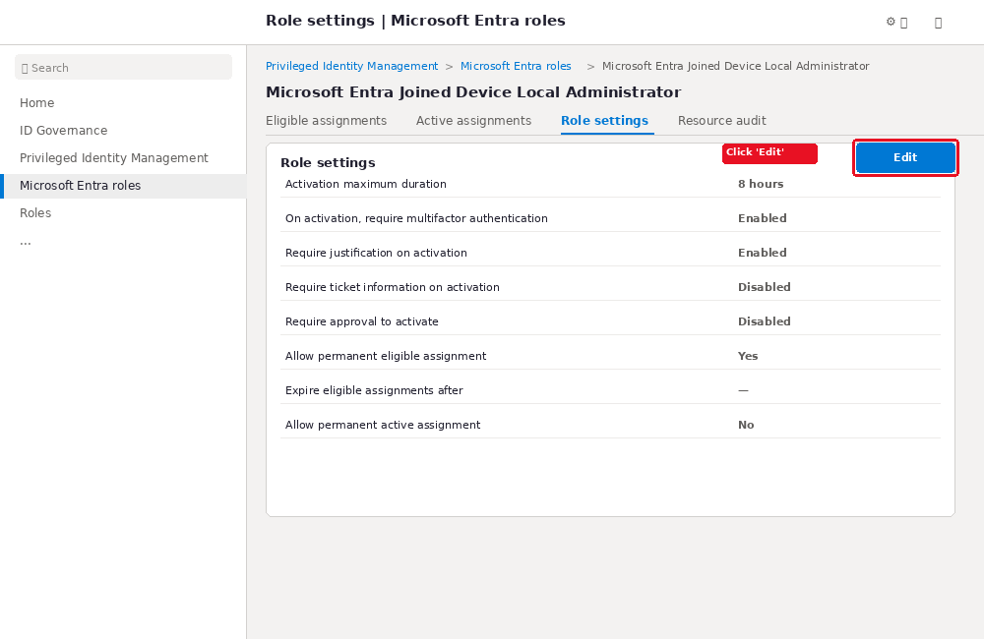
Figure 4. Illustrative portal mockup - Role settings page. Click "Edit" to modify the PIM policy.

Click Path:
- Select the "Role settings" tab.
- Review the current settings displayed on the page.
- Click "Edit" in the upper-right corner to enter edit mode.

4.3 Configure Activation Settings
Configure the activation requirements that support technicians must satisfy when elevating to the role. The following settings are recommended for the Microsoft Entra Joined Device Local Administrator role.
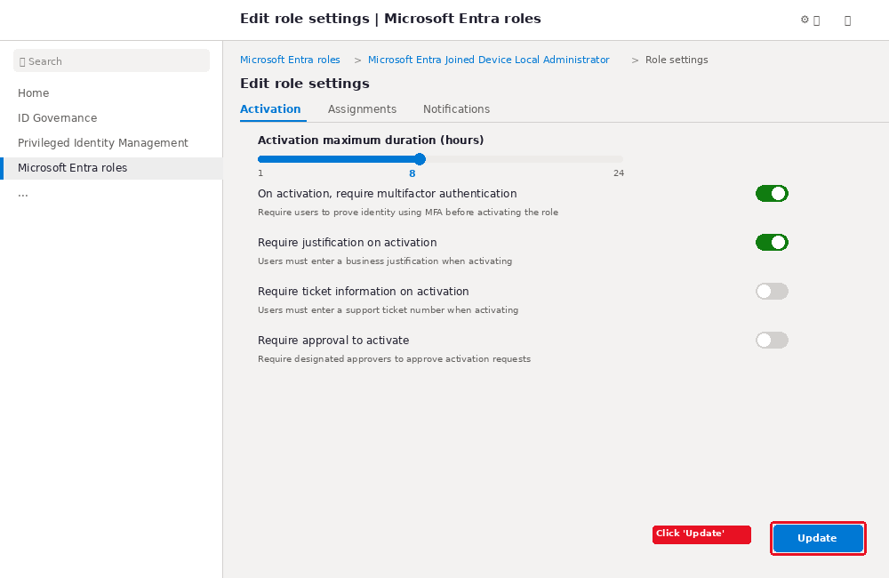
Figure 5. Illustrative portal mockup - Activation settings tab. Configure MFA, justification, duration, and approval.

Click Path:
- Activation tab should be active by default when editing role settings.
- Activation maximum duration: Set using the slider. Range is 1-24 hours. Recommended: 8 hours for support tasks.
- On activation, require multifactor authentication: Toggle ON. This requires users to prove their identity using MFA before activating the role.
- Require justification on activation: Toggle ON. Users must enter a business justification when activating.
- Require ticket information on activation: Optional. Toggle ON if your organization uses a ticketing system. This is an information-only field; correlation with ticketing systems is not enforced.
- Require approval to activate: Optional. Toggle ON if you want designated approvers to approve activation requests. If enabled, select at least two approvers.
- Click "Update" to save the activation settings.

Recommended Settings Table
Setting | Recommended Value | Purpose
Activation maximum duration | 8 hours | Sufficient for typical support tasks; limits exposure window
Require MFA on activation | Enabled | Ensures identity verification before elevation
Require justification | Enabled | Provides audit trail for why the role was activated
Require ticket information | Enabled | Links activations to support tickets for traceability
Require approval | Optional (recommended) | Adds an approval gate for high-security environments
Approvers (if approval enabled) | 2+ designated approvers | Prevents bottlenecks; Microsoft recommends at least two
Conditional Access Enhancement
For stronger security, enable "On activation, require Microsoft Entra Conditional Access authentication context" to enforce authentication strength policies (e.g., requiring Microsoft Authenticator passwordless sign-in even when the user signed in with Windows Hello for Business). This requires a pre-configured Conditional Access policy targeting the authentication context.

5. Configure Assignment Duration Settings
In addition to activation settings, configure the assignment duration settings that control how long eligible and active assignments can persist.

Assignment Settings (Assignment Tab):
- Allow permanent eligible assignment: Recommended: Yes. This allows permanent eligibility without expiration, which is appropriate for long-term support staff who need ongoing JIT access.
- Expire eligible assignments after: If you prefer time-bound eligibility, set a maximum duration (e.g., 6 months). Assignments expire and require renewal.
- Allow permanent active assignment: Recommended: No. Active (always-on) assignments should not be permanent for this role.
- Expire active assignments after: Set a maximum duration for any active assignments (e.g., 1 hour) if active assignments are allowed at all.
Best Practice
Keep zero permanently active assignments for the device local administrator role. Only use eligible assignments for support technicians. Reserve permanent active assignments for emergency break-glass accounts only.

Notifications Tab:
Configure who receives email notifications when role activations occur:
- Send activation notifications to Privileged Role Administrators (default)
- Add additional recipients (e.g., IT management email distribution list)
- Configure critical-only emails if you want to reduce notification volume
- The maximum number of notifications per event is 1,000 recipients

6. Assign Eligible Members
After configuring role settings, assign support technicians (or a support technician group) as eligible members of the Microsoft Entra Joined Device Local Administrator role. Eligible members must activate the role before using it.

6.1 Start the Add Assignment Wizard
From the Microsoft Entra roles page, initiate the assignment process.
Figure 6. Illustrative portal mockup - Click "+ Add assignments" from the Roles tab to start the assignment wizard.

Click Path:
- Select "Roles" tab from the Microsoft Entra roles page.
- Click "+ Add assignments" button in the upper-right area.

6.2 Select the Role and Members
Choose the target role and the users or groups to assign.
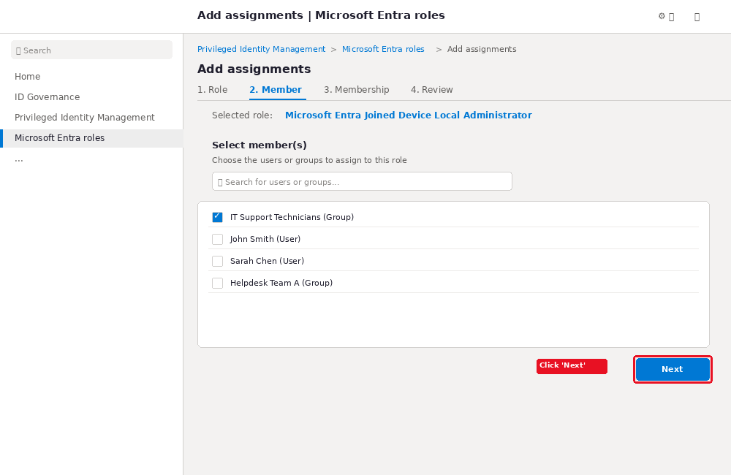
Figure 7. Illustrative portal mockup - Select the role and choose members to assign.

Click Path:
- Step 1 - Role: If not already selected, click "Select a role" and choose "Microsoft Entra Joined Device Local Administrator".
- Step 2 - Member: Click "Select member(s)" to open the member search. Search for individual users or groups.
- Check the box next to each user or group you want to assign. You can select users, groups, or agent identities.
- Click "Next" to proceed to membership settings.
Group Assignment
If assigning through a group, the group must be a cloud-only, role-assignable group (created in Microsoft Entra ID and marked as assignable to a role). You can assign only role-based groups to the Microsoft Entra Joined Device Local Administrator role.

6.3 Set Assignment Type to Eligible
The most important setting on the membership step is the assignment type. Select "Eligible" to require just-in-time activation.
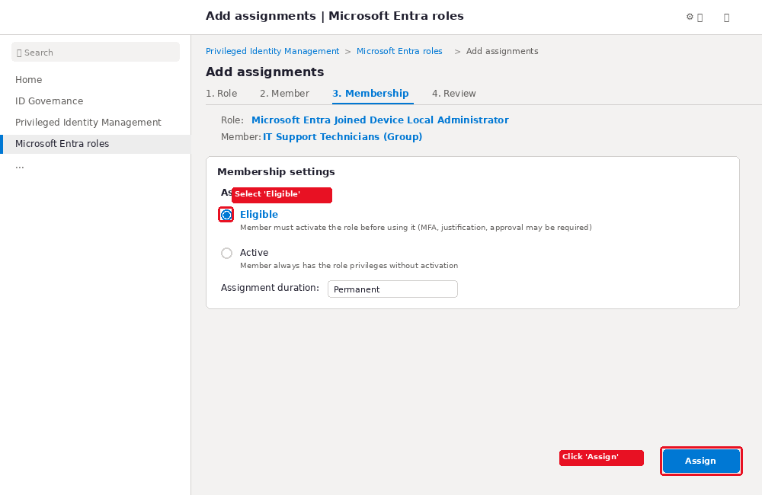
Figure 8. Illustrative portal mockup - Select "Eligible" as the assignment type. This enforces just-in-time activation.

Click Path:
- Assignment type: Select "Eligible". This requires the member to perform an action (MFA, justification, approval) before using the role.
- Assignment duration: Choose "Permanent" for ongoing support staff, or set a time-bound duration for temporary or contract workers.
- Click "Assign" to create the eligible assignment.
- A confirmation notification appears confirming the assignment was created.
Important
Eligible assignments do not grant the user any privileges until they actively activate the role. This is the core of just-in-time access - the user has no standing privileges.

7. Configure Device Local Administrator Role
The Microsoft Entra Joined Device Local Administrator role must also be configured at the device settings level. This is a separate configuration from PIM that controls which roles are assigned to the local Administrators group on all Microsoft Entra joined devices.

7.1 Access Device Settings
Navigate to the device settings page in the Microsoft Entra admin center.
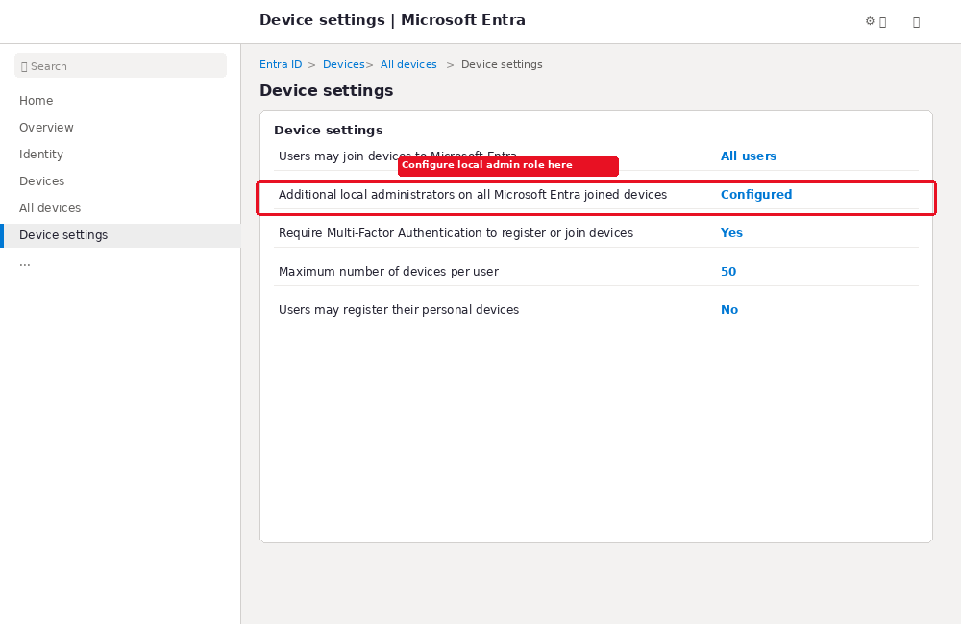
Figure 9. Illustrative portal mockup - Device settings page. The "Additional local administrators" setting applies the role to all Entra-joined devices.

Click Path:
- Sign in to the Microsoft Entra admin center as at least a Privileged Role Administrator.
- Browse to Entra ID > Devices > All devices > Device settings.
- Locate "Additional local administrators on all Microsoft Entra joined devices" setting.

7.2 How Device Local Admin Works
At the time of Microsoft Entra join, the following security principals are added to the local Administrators group on the device:
- The Microsoft Entra Joined Device Local Administrator role
- The Global Administrator role
- The user performing the Microsoft Entra join
Users assigned to the Microsoft Entra Joined Device Local Administrator role receive their permissions through the Primary Refresh Token (PRT). They are not directly listed in the local Administrators group on each device. This means their permissions are managed centrally through Entra ID, not by modifying local groups on each device.
Important: Timing for Privilege Changes
For users already signed in to an affected device, privilege elevation takes place when BOTH conditions occur:
- Up to 4 hours have passed for Microsoft Entra ID to issue a new Primary Refresh Token with the appropriate privileges
- The user signs out and signs back in (locking/unlocking does NOT refresh the profile)
For users who have not previously signed in to the relevant device, administrator privileges are applied immediately after their first sign-in.
When users are removed from the role, revocation can take up to 4 hours and requires the user to sign out and sign back in.

8. Technician Activation Workflow
This section describes the workflow that support technicians follow when they need to activate their local administrator role. This is the day-to-day process that replaces permanent local admin access with just-in-time elevation.

8.1 Navigate to My Roles
The technician signs in to the Microsoft Entra admin center and navigates to their eligible roles.
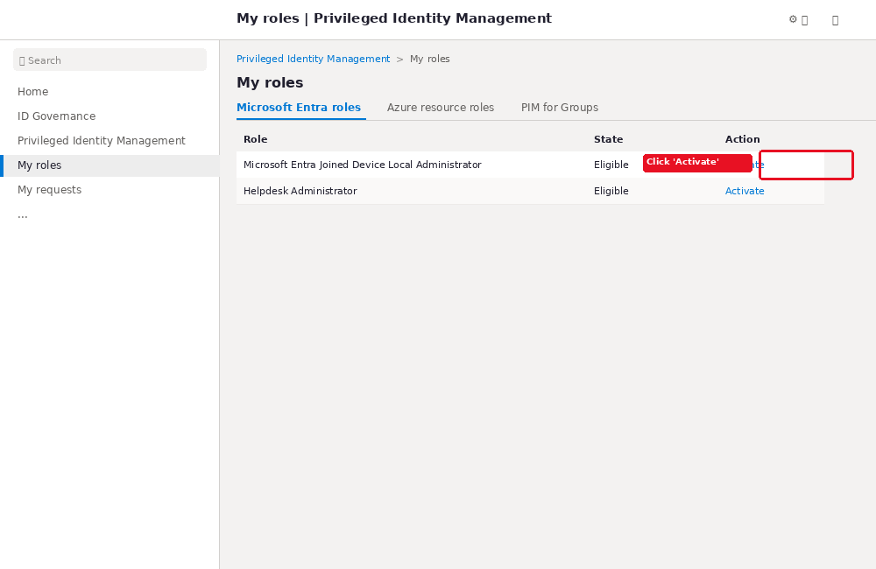
Figure 10. Illustrative portal mockup - My roles page. The technician clicks "Activate" to start the elevation process.

Click Path:
- Sign in to the Microsoft Entra admin center (https://entra.microsoft.com) using the technician account.
- Browse to ID Governance > Privileged Identity Management > My roles.
- Select "Microsoft Entra roles" tab to see eligible directory roles.
- Find "Microsoft Entra Joined Device Local Administrator" in the list.
- Click "Activate" to open the activation pane.

8.2 Complete MFA and Activation
The technician completes the required MFA challenge, enters a justification, and activates the role.
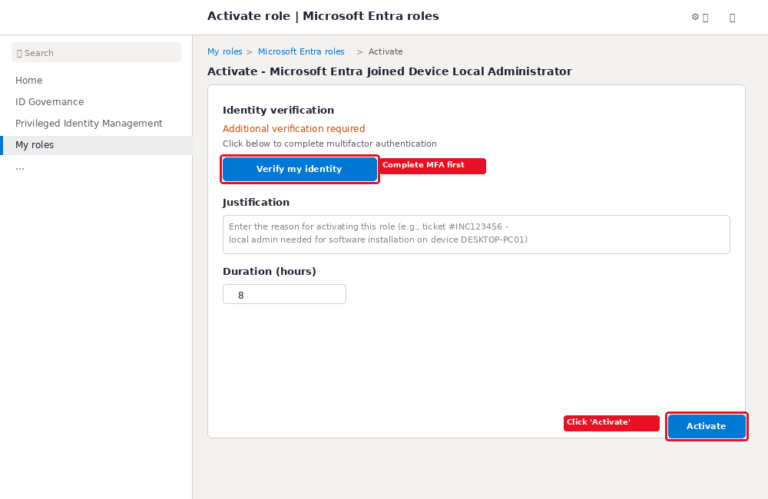
Figure 11. Illustrative portal mockup - Activation pane. Complete MFA, enter justification, and click Activate.

Click Path:
- Identity verification: Click "Verify my identity" to complete multifactor authentication. Authentication is required only once per session.
- Justification: Enter a business justification (e.g., "Ticket #INC123456 - local admin needed for software installation on device DESKTOP-PC01").
- Ticket information: If required, enter the support ticket number (information-only field).
- Duration: Select the activation duration (up to the maximum configured in role settings, e.g., 8 hours).
- Click "Activate" to submit the activation request.
If the role requires approval, a notification appears indicating the request is pending approval. The technician will receive an email when the request is approved or denied.

8.3 Activation Confirmed
Once activated (or approved), the role appears in the active assignments list with a countdown timer showing remaining time.
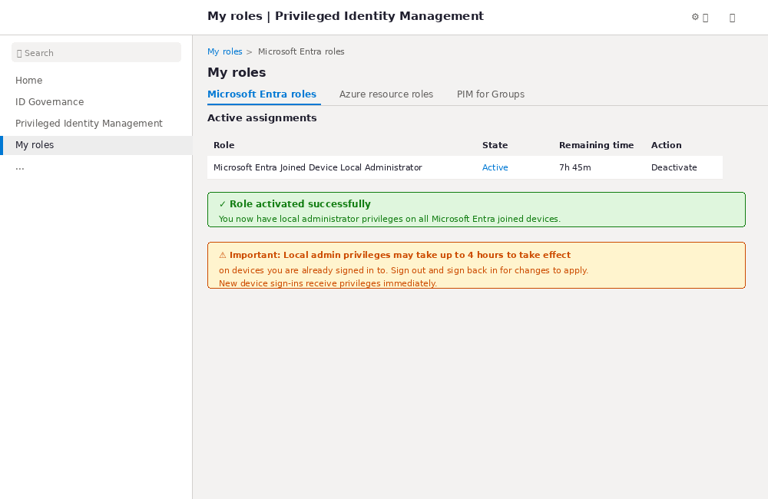
Figure 12. Illustrative portal mockup - Role activated successfully. Note the timing warning for privilege propagation.

Post-Activation Steps:
- The role is activated within seconds of clicking "Activate".
- For new device sign-ins: Local admin privileges are applied immediately on first sign-in to a device.
- For existing sessions: Sign out and sign back in to the device. Wait up to 4 hours for a new Primary Refresh Token to be issued.
- The role automatically deactivates when the activation duration expires. The technician can also manually deactivate earlier by clicking "Deactivate".
Critical Timing Note
If the technician is already signed in to the target device, they MUST sign out and sign back in for local admin privileges to take effect. Simply locking and unlocking the device does NOT refresh the Primary Refresh Token. The change can take up to 4 hours to propagate.
Verification on Device
After activation and sign-in, the technician can verify local admin access by right-clicking an application and selecting "Run as administrator", or by opening an elevated Command Prompt and running: net localgroup administrators. The Microsoft Entra Joined Device Local Administrator role grants elevation through the PRT, not by appearing in the local Administrators group list.

9. Monitoring and Auditing
Continuous monitoring of PIM activity is essential for maintaining security and compliance. This section covers audit history, security alerts, and access reviews.

9.1 View Resource Audit History
The Resource audit blade shows all activity related to role assignment and PIM policy management, including activations, deactivations, and assignment changes.
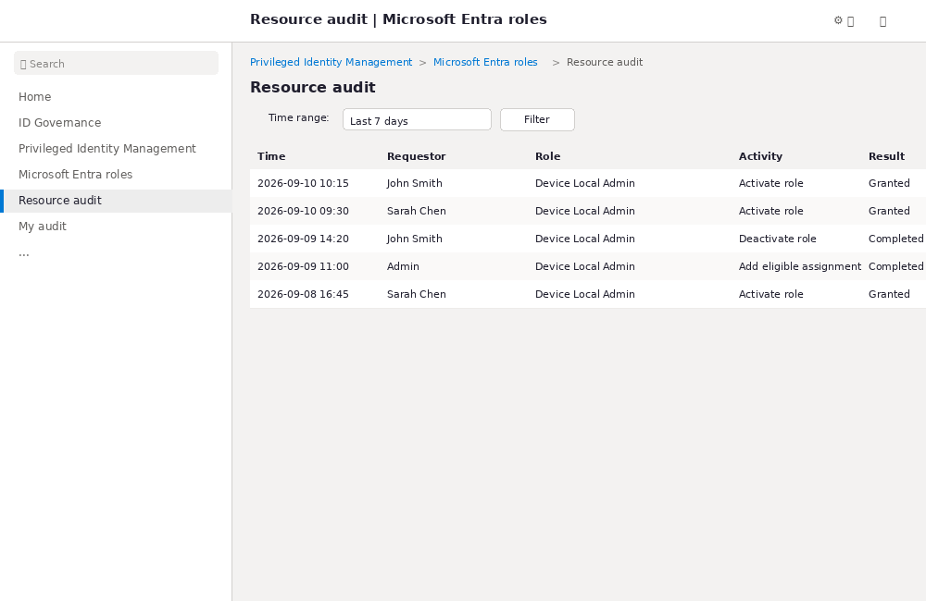
Figure 13. Illustrative portal mockup - Resource audit page showing role activation and assignment events.

Click Path:
- Sign in to the Microsoft Entra admin center as a Global Administrator, Global Reader, Privileged Role Administrator, Security Administrator, or Security Reader.
- Browse to ID Governance > Privileged Identity Management > Microsoft Entra roles > Resource audit.
- Filter the history using a predefined date range (e.g., "Last 7 days") or a custom range.
The audit history is available for the past 30 days. Microsoft recommends:
- Have at least one administrator review all audit events weekly
- Export audit events monthly for compliance records
- Monitor for unusual activation patterns (frequent activations, after-hours activations)

9.2 My Audit
Individual users can view their own role activity through the My audit blade:
- Browse to ID Governance > Privileged Identity Management > Microsoft Entra roles > My audit.
- Filter by date range to view personal activation history.

10. Configure Security Alerts
PIM provides built-in security alerts that detect suspicious or unsafe privileged role activity. Configure these alerts to receive notifications when potential security issues are detected.
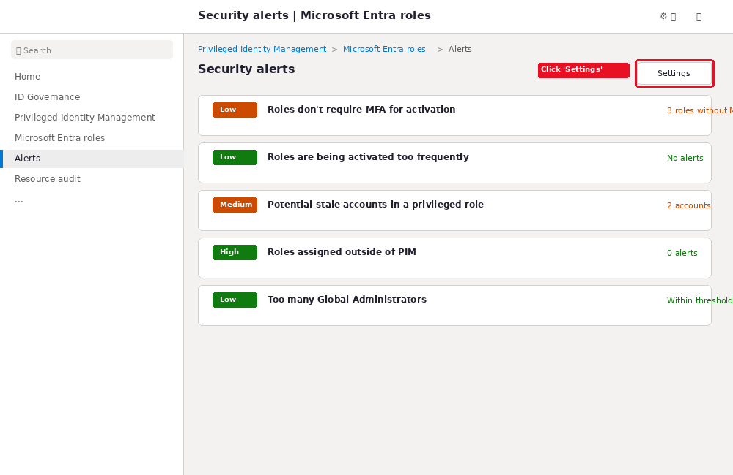
Figure 14. Illustrative portal mockup - Security alerts page. Click "Settings" to customize alert thresholds.

Click Path:
- Browse to ID Governance > Privileged Identity Management > Microsoft Entra roles > Alerts > Settings.
- Customize alert thresholds for your organization environment and security goals.

10.1 Key Security Alerts to Configure
Setting | Recommended Value | Purpose
Alert | Recommended Threshold | Purpose
Administrators not using privileged roles | 30 days | Identify unused eligible assignments for removal
Roles without MFA for activation | Fix immediately | Ensure all roles require MFA
Potential stale accounts in privileged role | 90 days | Remove inactive accounts from privileged roles
Roles assigned outside of PIM | Investigate all | Detect direct assignments bypassing PIM
Roles activated too frequently | 3 per 24 hours | Detect suspicious activation patterns
Too many Global Administrators | Per org policy | Minimize Global Admin count
Alert severity levels:
- High: Requires immediate action due to a policy violation
- Medium: Signals a potential policy violation, no immediate action needed
- Low: Suggests a preferable policy change, no immediate action needed
Email Notifications
For the "Roles are being assigned outside of Privileged Identity Management" alert (High severity), emails are sent to Privileged Role Administrators, Security Administrators, and Global Administrators who have enabled PIM. Ensure the alert and its email notification are enabled in the alert settings.

11. Set Up Access Reviews
Access reviews provide a recurring, automated process to verify that users still need their eligible role assignments. They help identify and remove unnecessary privileged access over time.

11.1 Create an Access Review
Create a recurring access review for the Microsoft Entra Joined Device Local Administrator role.
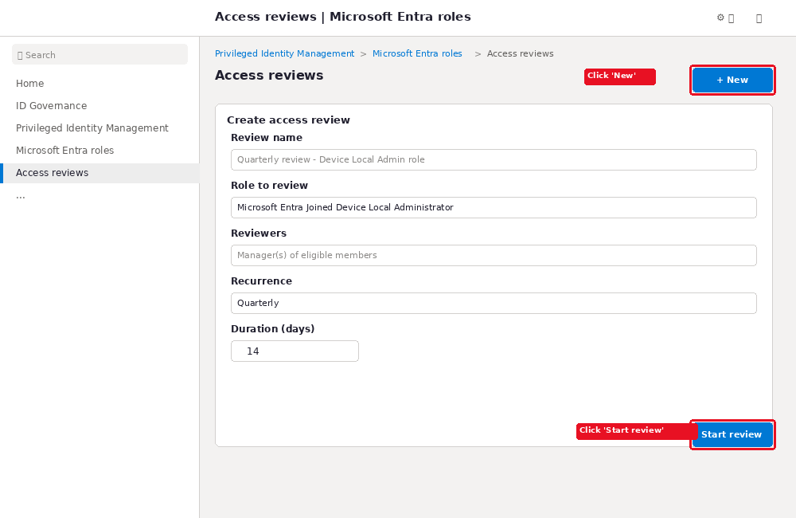
Figure 15. Illustrative portal mockup - Access review creation form with role, reviewers, and recurrence configuration.

Click Path:
- Browse to ID Governance > Privileged Identity Management > Microsoft Entra roles > Access reviews.
- Click "+ New" to create a new access review.
- Review name: Enter a descriptive name (e.g., "Quarterly review - Device Local Admin role").
- Role to review: Select "Microsoft Entra Joined Device Local Administrator".
- Reviewers: Select managers of eligible members, or designate specific reviewers (e.g., IT manager, security officer).
- Recurrence: Set to Quarterly (every 3 months) for ongoing review.
- Duration: Set to 14 days to give reviewers sufficient time.
- Click "Start review" to begin the first review cycle.

11.2 Access Review Best Practices
- Use access reviews to automate discovery, review, approval, and removal of assignments
- Schedule reviews at least quarterly for privileged roles
- Configure auto-apply settings to automatically remove denied users from eligible assignments
- Send reminder notifications to reviewers who have not completed their reviews
- Document review outcomes for audit and compliance purposes

12. Governance Best Practices
Follow these governance best practices to maintain a secure and compliant PIM implementation for the device local administrator role.

12.1 Least Privilege
- Assign support technicians only the Microsoft Entra Joined Device Local Administrator role - do not assign broader roles like Global Administrator or Intune Administrator
- Use the minimum activation duration that covers the support task (e.g., 4 hours instead of 8 if the task is short)
- Scope eligible assignments to role-assignable groups when possible, to simplify management

12.2 Separate Admin Accounts
- Support technicians should use separate admin accounts for privileged operations, distinct from their daily-use accounts
- Admin accounts should not have mailbox, Teams, or other productivity workload licenses
- Admin accounts should be enrolled in MFA with strong authentication methods

12.3 Conditional Access for Admins
- Apply Conditional Access policies to all eligible users (e.g., require compliant device, trusted IP, or specific authentication strength)
- Consider scoping Conditional Access to eligible users so they must always use compliant devices, even when not activating
- Use authentication context in PIM settings for stronger activation-time controls

12.4 Break-Glass Accounts
- Maintain at least two cloud-only emergency access accounts with permanent active Global Administrator assignments
- Exclude break-glass accounts from PIM and MFA lockout policies
- Do not assign break-glass accounts to specific individuals
- Monitor break-glass account sign-in activity and alert on any usage
- Rotate break-glass account passwords at regular intervals (quarterly or yearly)

12.5 No Shared Accounts
- Never share admin account credentials among technicians
- Each technician should have their own eligible assignment or be a member of a role-assignable group
- Rotate passwords for any shared service accounts assigned to privileged roles immediately when staff changes occur

12.6 Assignment Expiry
- Use time-bound eligible assignments for contractors and temporary staff with known end dates
- Configure assignment expiry settings to prevent indefinite assignments
- Review and renew expiring assignments through the PIM extension/renewal workflow (requires Global Admin or Privileged Role Administrator approval)

13. Troubleshooting Guide
This section covers common issues encountered during PIM implementation and their solutions.

13.1 Role Not Visible in PIM
- Cause: The user may not have the Privileged Role Administrator or Global Administrator role.
- Solution: Ensure the administrator configuring PIM has at least the Privileged Role Administrator role.

13.2 Activation Request Denied
- Cause: Approval is required and the approver denied the request, or no approvers are configured.
- Solution: If approval is required, ensure at least two approvers are configured. If no approvers are selected, active Privileged Role Administrators and Global Administrators become default approvers.

13.3 MFA Not Prompted During Activation
- Cause: The user may have already completed MFA earlier in the session, or authenticated with strong credentials.
- Solution: To enforce reauthentication on every activation, configure Conditional Access authentication context with sign-in frequency set to "Every time" in the session controls.
- Note: There is a 10-minute window after one activation during which another activation does not prompt for reauthentication.

13.4 Local Elevation Not Working After Activation
- Cause: The Primary Refresh Token has not been refreshed, or the user has not signed out and back in.
- Solution: The user must sign out and sign back in to the device. Privilege changes can take up to 4 hours to propagate. Locking and unlocking does NOT refresh the profile.

13.5 Device Not Entra Joined
- Cause: The device may be Entra registered or hybrid joined instead of Entra joined.
- Solution: Verify the device join type in Entra ID > Devices > All devices. The Microsoft Entra Joined Device Local Administrator role only applies to Entra joined devices, not Entra registered or hybrid joined devices.

13.6 Wrong Account Used
- Cause: The technician may be signed in with their daily-use account instead of their admin account.
- Solution: Ensure the technician signs in with the account that has the eligible assignment. If using separate admin accounts, verify the correct account is being used for both portal access and device sign-in.

13.7 Tenant Lockout Risk
- Cause: All Privileged Role Administrators and Global Administrators have eligible assignments (not active), approval is required, and no approvers are configured.
- Solution: Configure emergency access accounts with permanent active Global Administrator assignments, excluded from PIM and MFA. Always designate specific approvers when approval is required.

14. Rollback and Emergency Procedures

14.1 Rollback: Revert Eligible to Active Assignment
If PIM does not work as desired in production, you can revert eligible assignments to active assignments to restore permanent access while troubleshooting:
- Sign in to the Microsoft Entra admin center as a Privileged Role Administrator.
- Browse to ID Governance > Privileged Identity Management > Microsoft Entra roles > Roles.
- Select the Microsoft Entra Joined Device Local Administrator role.
- Find the user whose assignment type is "Eligible" on the Eligible roles tab.
- Click the ellipsis (...) next to the assignment.
- Select "Make active" to convert the eligible assignment to an active one.

14.2 Remove Eligible Assignment
To completely remove an eligible assignment:
- Navigate to the role detail page in PIM.
- Find the assignment on the "Eligible roles" or "Active roles" tab.
- Click "Remove" to delete the assignment.

14.3 Emergency Local Admin Access
If PIM is unavailable or a technician needs immediate local admin access outside of PIM:
- Use a break-glass account with permanent active Global Administrator assignment (which includes local admin on all Entra joined devices)
- Manually elevate a user on a single device using Windows Settings > Accounts > Other users > Add a work or school user (requires existing local admin access)
- Use Command Prompt: net localgroup administrators /add "AzureAD\<UserUPN>" (requires existing local admin access)
- Document the emergency access in an incident report and review the PIM configuration to prevent recurrence

15. Implementation Summary Checklist

Preparation
- Microsoft Entra ID P2 or Governance licenses confirmed
- Privileged Role Administrator access confirmed
- Support technician group or individual users identified
- Break-glass accounts created and excluded from PIM
- Pilot plan documented and test users created

Configuration
- PIM role settings configured for Microsoft Entra Joined Device Local Administrator
- MFA required on activation
- Justification required on activation
- Activation maximum duration set (e.g., 8 hours)
- Approval configured (if required) with at least two approvers
- Notifications configured for administrators
- Eligible assignments created for support technicians or group
- Device settings verified for additional local administrators

Validation
- Test user activated role successfully
- MFA challenge completed during activation
- Justification recorded in audit log
- Local admin access verified on a test Entra-joined device
- Role auto-deactivated after expiration

Ongoing Operations
- Security alerts configured and monitored
- Resource audit reviewed weekly
- Audit events exported monthly
- Quarterly access reviews scheduled
- Eligible assignments reviewed for necessity
- Communications distributed to support technicians

Document References: This guide references official Microsoft Learn documentation for Microsoft Entra Privileged Identity Management, device local administrator management, and PIM deployment planning. All portal navigation paths, button names, and settings options are based on current Microsoft documentation as of September 2026. Illustrations are mockups created for training purposes and are not actual screenshots of the Microsoft Entra portal.

Microsoft Learn - What is Privileged Identity Management?, https://learn.microsoft.com/en-us/entra/id-governance/privileged-identity-management/pim-configure
Microsoft Learn - Plan a Privileged Identity Management deployment, https://learn.microsoft.com/en-us/entra/id-governance/privileged-identity-management/pim-deployment-plan
Microsoft Learn - Plan a Privileged Identity Management deployment, https://learn.microsoft.com/en-us/entra/id-governance/privileged-identity-management/pim-deployment-plan
Microsoft Learn - Configure Microsoft Entra role settings in PIM, https://learn.microsoft.com/en-us/entra/id-governance/privileged-identity-management/pim-how-to-change-default-settings
Microsoft Learn - Assign Microsoft Entra roles in PIM, https://learn.microsoft.com/en-us/entra/id-governance/privileged-identity-management/pim-how-to-add-role-to-user
Microsoft Learn - How to manage local administrators on Microsoft Entra joined devices, https://learn.microsoft.com/en-us/entra/identity/devices/assign-local-admin
Microsoft Learn - How to manage local administrators on Microsoft Entra joined devices, https://learn.microsoft.com/en-us/entra/identity/devices/assign-local-admin
Microsoft Learn - Activate Microsoft Entra roles in PIM, https://learn.microsoft.com/en-us/entra/id-governance/privileged-identity-management/pim-how-to-activate-role
Microsoft Learn - View audit log report for Microsoft Entra roles in PIM, https://learn.microsoft.com/en-us/entra/id-governance/privileged-identity-management/pim-how-to-use-audit-log
Microsoft Learn - Security alerts for Microsoft Entra roles in PIM, https://learn.microsoft.com/en-us/entra/id-governance/privileged-identity-management/pim-how-to-configure-security-alerts
Microsoft Learn - Plan a Privileged Identity Management deployment, https://learn.microsoft.com/en-us/entra/id-governance/privileged-identity-management/pim-deployment-plan
Microsoft Learn - Plan a Privileged Identity Management deployment, https://learn.microsoft.com/en-us/entra/id-governance/privileged-identity-management/pim-deployment-plan

